20/09/2020

**Experiment No:6**

**STACK USING ARRAY**

**AIM:**

Implement a Stack using arrays with the operations:

1.Pushing elements to the Stack.

2.Popping elements from the Stack

3.Display the contents of the Stack after each operation.

**DATA STRUCTURES USED:**

Stack

**ALGORITHM:**

Algorithm Push(x)

1. if top=size-1
2. print “stack overflow”
3. else
4. arrr[++top]=x
5. endif

Algorithm Pop()

1. if top = -1
2. print “stack is empty”
3. else
4. item =arr[top]
5. top—
6. endif

**PROGRAM:**

#include <stdio.h>  
#include <stdlib.h>  
struct stack{  
 int size;  
 int top;  
 int *arr;  
};  
  
int isFull(struct stack *st){  
 if(st->top >= st->size-1){  
 return 1;  
 }  
 return 0;  
}  
  
int isEmpty(struct stack *st){  
 if(st->top == -1){  
 return 1;  
 }  
 return 0;  
}  
  
void push(struct stack *st,int pushitem){  
 if(isFull(st)){  
 printf("\nStack Overflow\n\n");  
 }  
 else{  
 st->arr[++st->top] = pushitem;  
 }  
}  
int pop(struct stack *st){  
 if(isEmpty(st)){  
 printf("\nStack Underflow\n\n");  
 }  
 else{  
 int popitem = st->arr[st->top];  
 st->top--;  
 return popitem;  
 }  
}  
  
void display(struct stack *st){  
 printf("\nCURRENT STACK:\n");  
 for(int i=st->top; i>=0; i--){  
 printf("%d\n", st->arr[i]);  
 printf("\n");  
 }  
}  
  
void main(){  
 struct stack st;  
 int n,x,y;  
 char ans='y';  
 printf("Enter stack size :");  
 scanf("%d", &st.size);  
 st.arr = (int*) malloc (st.size * sizeof(int));  
 st.top = -1;  
 while(ans=='y'){  
 printf("\n--- OPERATION ON STACK --- \n\n");  
 printf(" 1. PUSH \n");  
 printf(" 2. POP\n");  
 printf(" 3. DISPLAY\n");  
 printf(" 4. EXIT\n");  
 printf("Enter the Choice (1/2/3/4): ");  
 scanf("%d",&n);  
 switch(n){  
 case 1:printf("--- PUSH ---\n");  
 printf("\nEnter element to be PUSHED :");  
 scanf("%d", &x);  
 push(&st,x);  
 break;  
 case 2:printf("--- POP ---\n");  
 y=pop(&st);  
 printf("\nElement %d POPED ",y);  
 break;  
 case 3:printf("--- DISPLAY ---\n");  
 display(&st);  
 break;  
 case 4:ans='n';  
 break;  
 default:printf("Enter a Valid Input\n");  
 }  
 }  
}

**OUTPUT:**

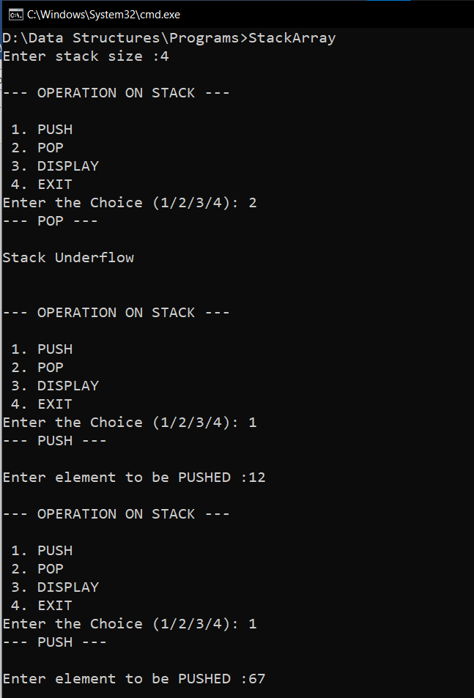

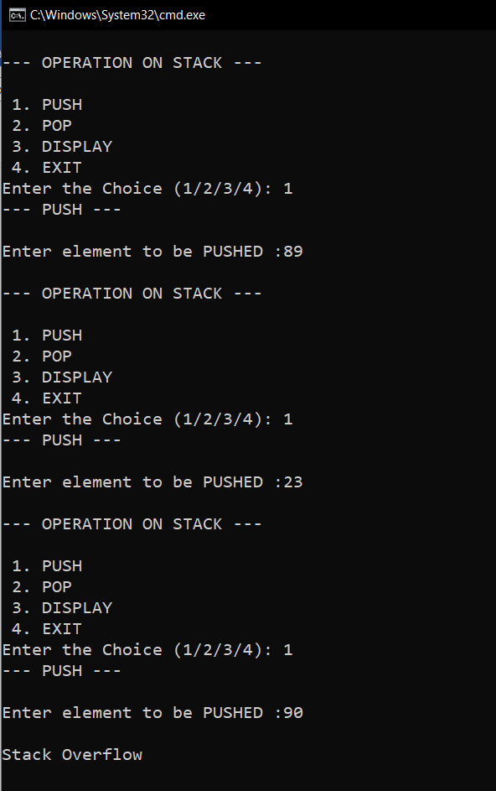

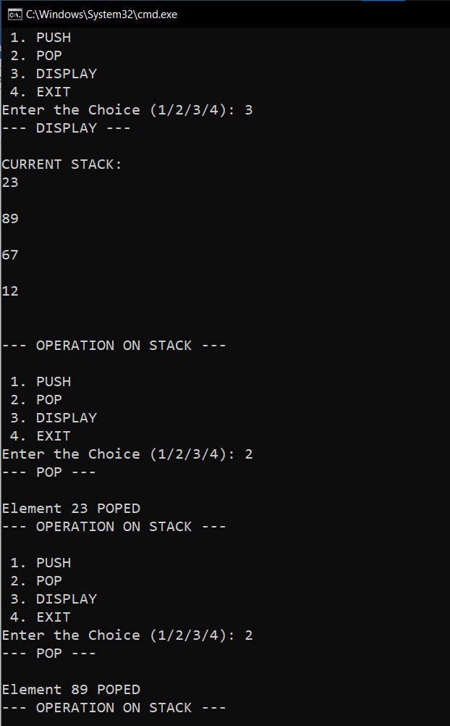

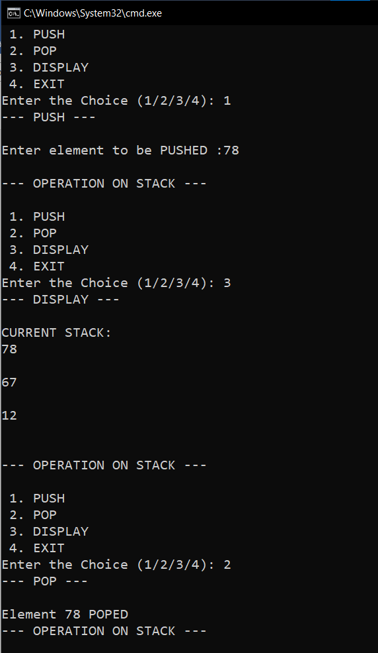

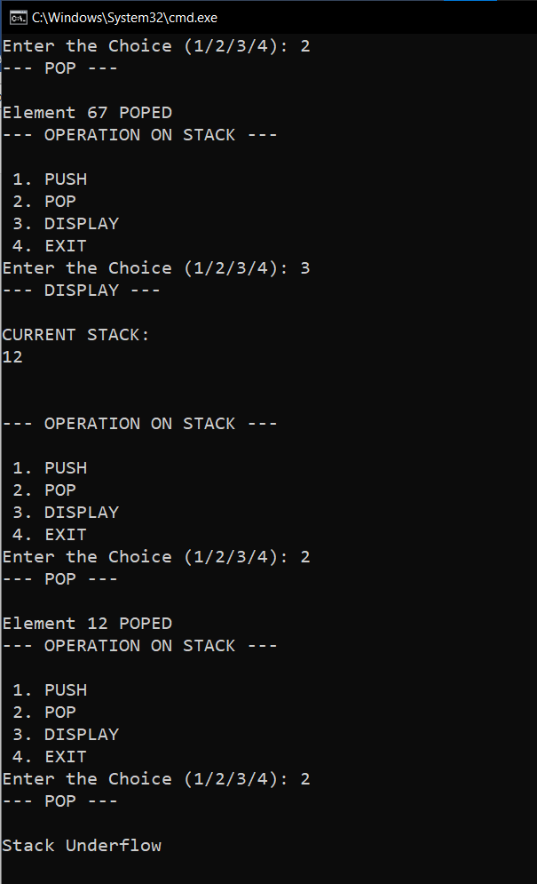

**RESULT:**

A Stack data structure is implemented using an array. Push(), Pop() and Display() operations were performed on it.